New Style Creation and Modification in MS Word

The following screen shots and directions relate directly to using MS Word 2003 on a Windows XP Pro operating system. If you are using an earlier version of the MS Word program or are working on an Apple Macintosh computer with MS Word the location of some controls and windows may be different but the steps are the same to work with style creation. Look around to find the necessary controls or ask me for assistance.

To begin, select Styles and Formatting… under Format in the Menu bar.
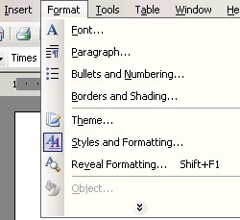

To the right of your screen this window will appear (below).
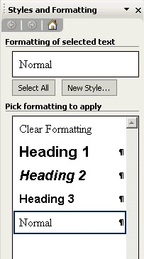

To create a new style, click on the New Style… button.
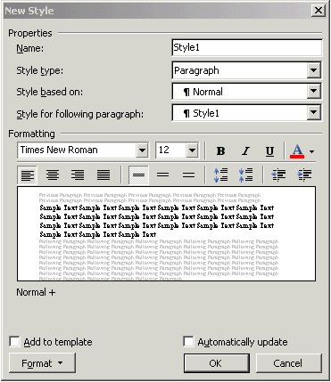

Name your new style in Properties: Name: (per the instructions -- <Your Initials StyleName>.)
Select the Style Type: (for this assignment all styles will use Paragraph.)
Select the Style based on: (each style being created specifies the Style based on: in its description. It is the first name listed and always to the left of the + sign.)
Select the Style for the following paragraph: (you do not have to change this setting but may if you choose to.)
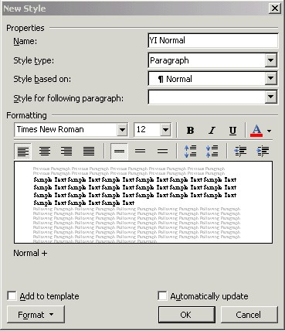
You may choose your Font in this screen (above) and . . .
as shown here (below) . . .
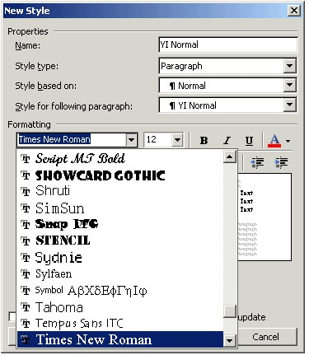

or you can click on Format at the bottom left … (below)
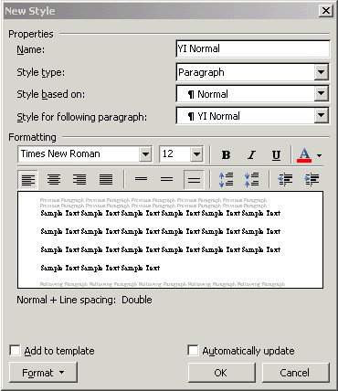
and select Font… to open a separate window with more options (below).
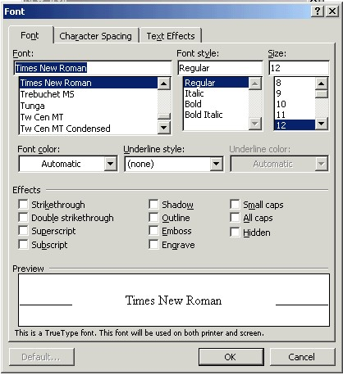

Click OK after making your choices.

Returning to the New Style window click on Format (bottom left corner) and select Paragraph… to go to the following window. Make changes to match what is shown.
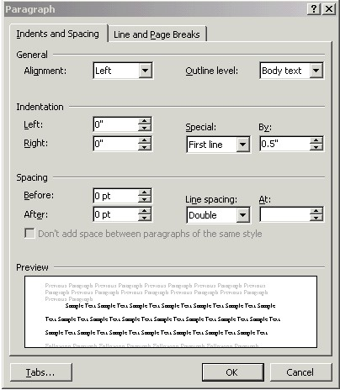

Click OK when finished to return to the New Style window.
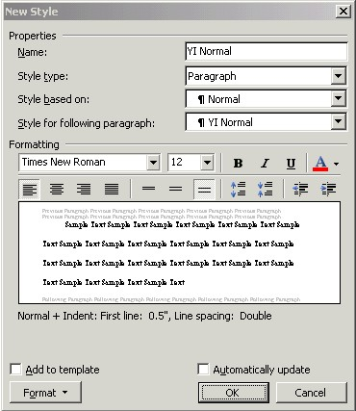

Returning to the New Style window (above) you will see the description of your style below the preview pane. If correct, click OK.

This style (YI Normal) will be used for the body of your paper with the exception of paragraphs requiring the use of the YI Block Text or YI Bullet List styles that you create.

Your new style will be listed as shown below.
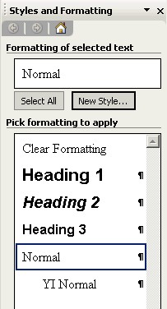

Again click on New Style… to create your next style.
This style will be used to center the titles at the beginning of the body of your paper and on the reference page. Make the choices as you did with your first style. Enter the style Name.. Select the correct Style based on: for your new style.
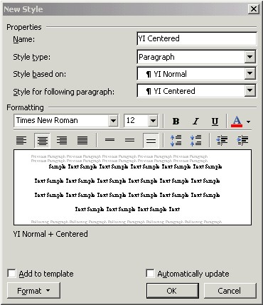

Select Format…/Paragraph… to open this window (below) … change it to match these settings.
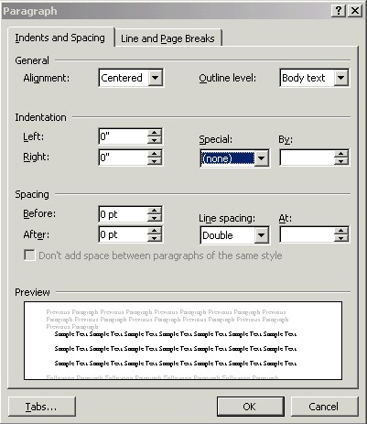

When complete click OK.
Check your description (below) and if correct click OK.
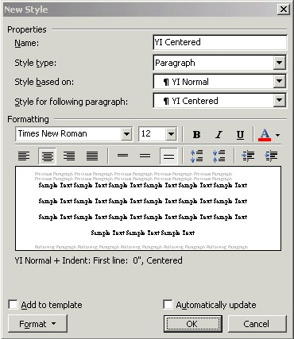

Your new style is added to the list.
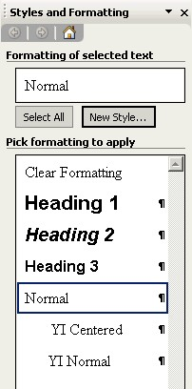

Proceed as before…

You will now create the style to be used for your cover page.
For this style you will enter the Name and then set the Style based on: (below).
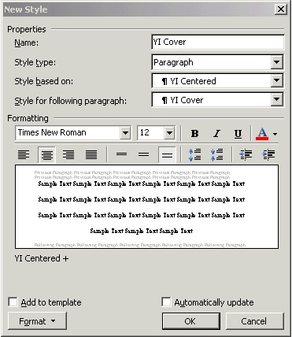

Then select Format…/Frame… (above) to go to this window (shown below).
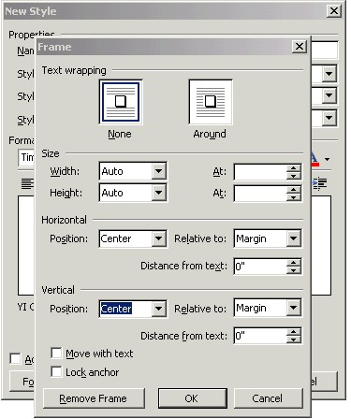

Here you will select Text Wrapping/None. Set Horizontal/Position: Center, Relative to: Margin. Set Vertical/Position: Center, Relative to: Margin. Distance from text: will use the default for each. Click OK when complete.
Check your description (below) and if correct click OK.
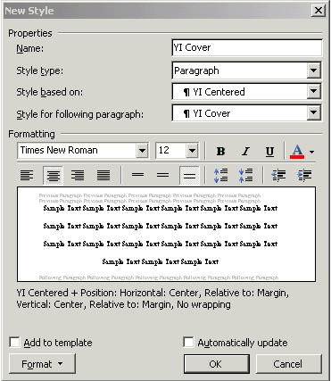

Your new style is added to the list.
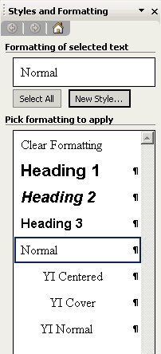

Proceed as before…
This style will be used to position the header information in your paper. For this style enter the Name and then set the Style based on: (below).
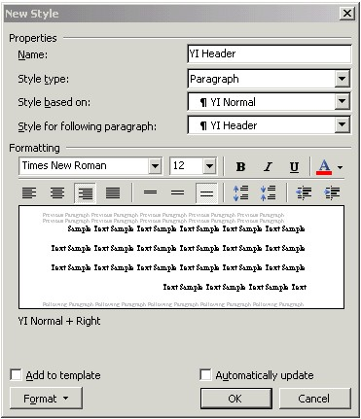

Select Format…/Paragraph… to open this window (below) … change it to match these settings.
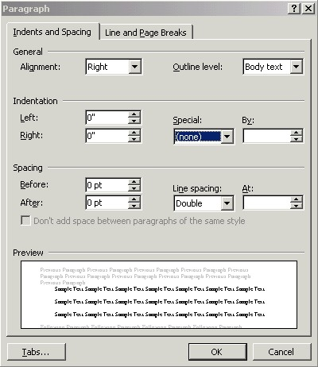
Check your description (below) and if correct click OK.
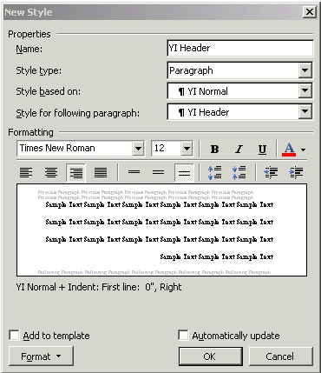

Your new style is added to the list.
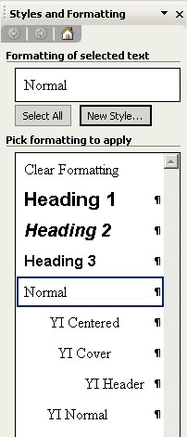

Proceed as before…
This style will be used to position the references in your paper. For this style enter the Name and then set the Style based on: (below).
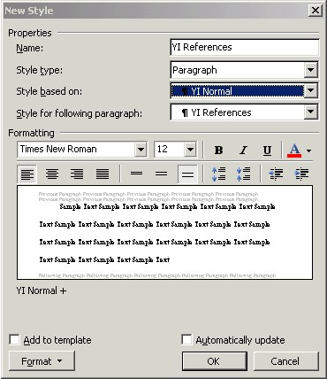

Select Format…/Paragraph… to open this window (below) … change it to match these settings.
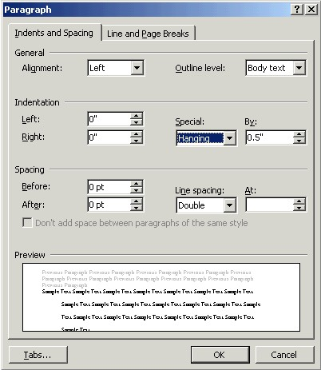
Check your description (below) and if correct click OK.
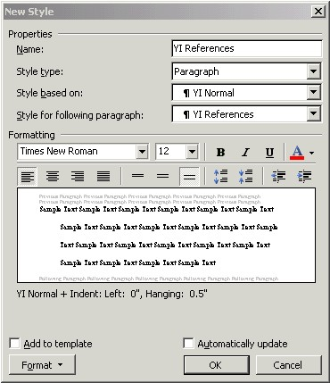

Your new style is added to the list.
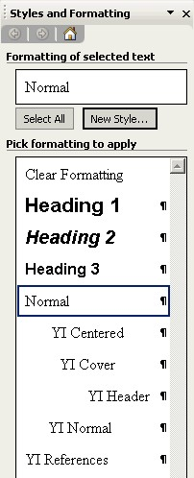

Proceed as before…
This style will be used to position any bullet listed items in your paper. For this style enter the Name and then set the Style based on: (below).
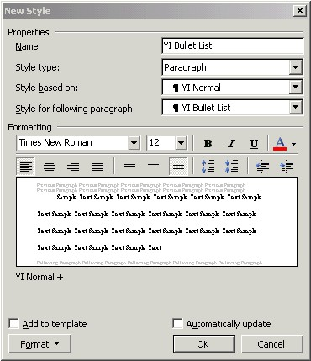

Select Format…/Numbering… to open this window (below) … change it to match these settings.
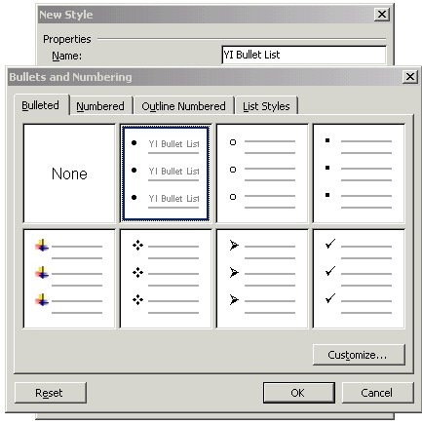
Click OK when complete.
The style will look like this (below).
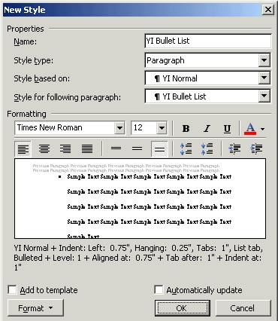

Now select Format…/Tabs… to open this window (below) …
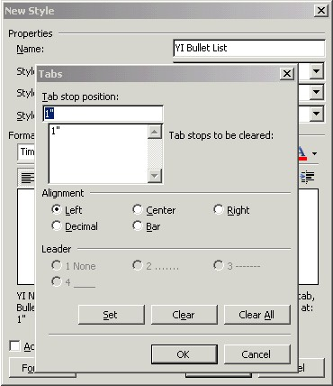

and change it to match the settings in the next window.
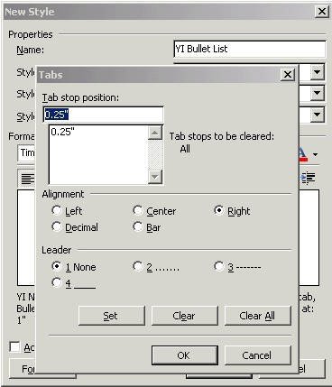
Match the settings above and click OK.
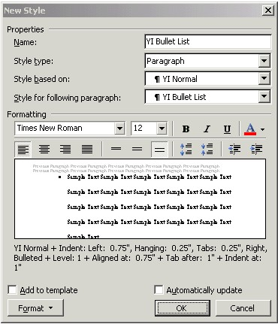

Now select Format…/Paragraph…
to open this window (below).
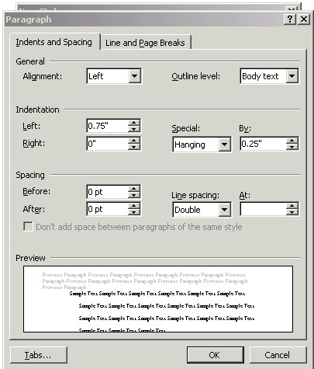

Now change it to match these settings (below).
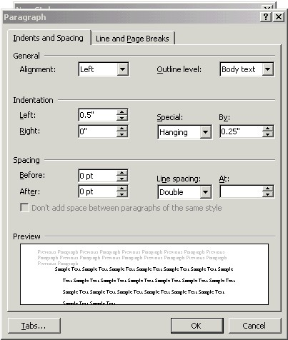
Click OK when complete.
Check your description (below) and if correct click OK.
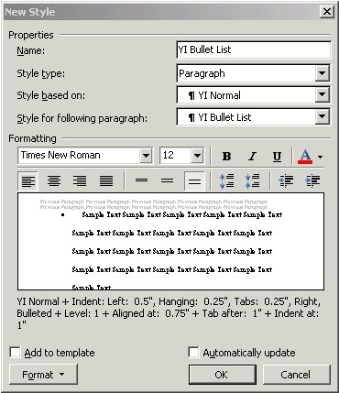

Your new style is added to the list.
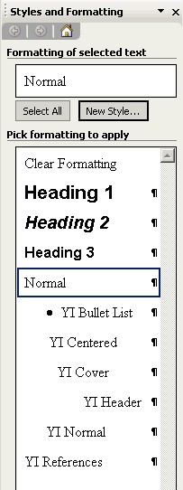
Proceed as before…
This style will be used to position any 40+ word quotation in your paper. For this style enter the Name and then set the Style based on: (below).
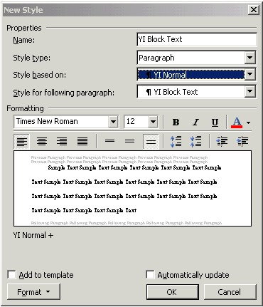

Select Format…/Paragraph… to open this window (below) … change it to match these settings.
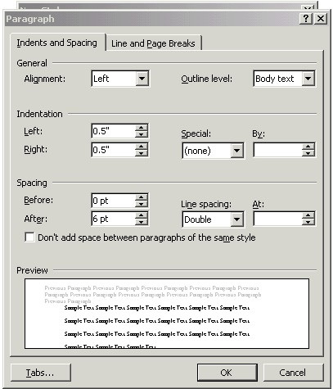

Click OK when complete.
Check your description (below) and if correct click OK.
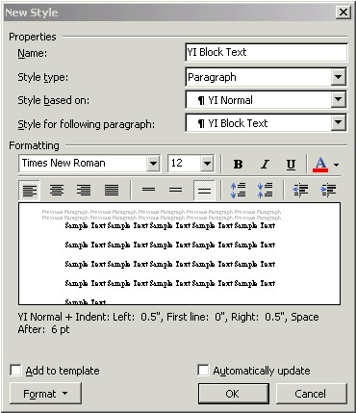

Your new style is added to the list.
