Cognitive Studies Program

2012 Self-Study Program Review

California State University, Stanislaus
Program previously underwent review for program discontinuation

A. Changes Since Program Discontinuation Review
- Describe actions taken in response to the recommendations made in the program discontinuation review.

During its last review, the Cognitive Studies Program was recommended for discontinuation by the UEPC. As a result of that recommendation, a committee was formed, chaired by Dr. James Klein, to carry out the mandated review process. The primary outcome of the review process was that the Academic Senate voted unanimously to continue the program.
A significant part of the review process was an external review by Dr. Steve Palmer from UC Berkeley. Dr. Palmer’s review was extensive and in depth, and contained a number of recommendations. These recommendations played a significant role in attempts to re-form the Cognitive Studies program following the review process. We will use these recommendations to frame discussion of actions taken since then. We will quote relevant portions of the Palmer report and recommendations.
- There are only two real choices: keep the program as a major and figure out ways to support it so that it is viable within the CSU Stanislaus campus context, or shut it down and let the chips fall where they may. The alternatives suggested in previous reviews -- making it a minor, turning it into an area of concentration within CS, or making it a graduate program -- simply do not make sense.

Following this recommendation, the Academic Senate voted to continue the program as an undergraduate major.
- Department chairs do not like having to release their faculty to teach in the program; faculty do not like having to teach COGS courses as overload if there is no released time in which to do it; and departments have no motivation to encorporate COGS courses into their own major programs. The net effect is to create a political and economic climate in which this interdisciplinary program -- indeed, any interdisciplinary program -- is likely to fail.
  - These issues continue to plague the Cognitive Studies program, and other interdisciplinary or multi-disciplinary programs on our campus. Budgeting and resource allocations are almost entirely at the department level. This becomes particularly difficult during times of tight resources such as the recent (and current) national and state economic downturn. In practice, this has meant that even less resources are directed toward Cognitive Studies than was the case at the time of the Palmer review. There is no assigned time for a Cognitive Studies coordinator. Several Cogs courses required for the major are largely being taught as overloads (such as Cogs 2300, Cogs 4100, and Cogs 4960).
  - The situation for interdisciplinary programs such as Cognitive Studies became even more difficult when the campus changed the College structure. When we had a College of Arts, Letters and Sciences, all the departments and programs contributing faculty time and course offerings supporting Cognitive Studies were in the same College, under the same Dean. This made it at least possible for there to be somewhat coherent support for interdisciplinary programs. When ALS was broken up, contributing departments / programs were scattered across three or four colleges. During the process of splitting ALS, the issue of interdisciplinary programs was raised. It was suggested that such programs should report directly to the Provost, and there were even claims that reporting directly to the Provost would raise the status and visibility of interdisciplinary programs. In practice, the Provost never played any role with respect to the Cognitive Studies program. The program “reported to” the Dean of whichever College the coordinator happened to be in.
  - The result of budgetary constraints and administrative restructuring has resulted in even less support for Cognitive Studies than before. In practice Cognitive Studies has only survived to the extent it has through efforts and contributions by individual faculty members. At the present time, these faculty are in the Computer Science, Psychology, and Philosophy departments.
- Improve the climate for interdisciplinary programs. Resources of standard departments can be shared with the interdisciplinary program for mutual benefit rather than being withheld for selfish interests. Until you manage to bring about this change in outlook among the units on your campus, I suspect that interdisciplinary studies programs of all sorts will flounder and eventually be forced out of existence.
Unfortunately, as noted above, it seems things have gotten worse rather than better for interdisciplinary programs on our campus. At this point, there is not even assigned time for a Cognitive Studies Coordinator. There has never even been a single faculty member officially assigned half-time to the Program.
- Crosslist as many COGS courses as possible.
  - We have crosslisted Cogs 3100 / CS 3000 – Communication Networks, Cogs 3150 / CS 3150 – Nonlinear Systems, Cogs 4400 / Psyc 4400 – Psychology of Workplace Performance, and Cogs 4700 / Psyc 4700 - Intelligence. Cogs 4350 is double listed with Hons 3050.
  - Another approach we have taken is to offer a variety of the Cogs classes as fully online classes. These include Cogs 2100, Cogs 2300, Cogs 4100 and Cogs 4960. A result of this is that there have been significant increases in enrollments in these classes. In an online format, many more students with relevant interest and background are taking the classes. For example, Cogs 2100 has had as many as 63 students enrolled in a single semester, and Cogs 4100 has had as many as 34 students enrolled. Also, Cogs 2100, Cogs 4100 and Cogs 4350 satisfy General Education requirements which also adds to their attractiveness to students.
- Restructure the Cognitive Studies Major.
We significantly restructured the major. We reduced the number of Cogs courses required, replaced some specialized requirements, and simplified the electives by eliminating the previous three categories of electives. This has had the effect of streamlining and clarifying the requirements for the major. However, a variety of the important courses for the major are offered on an alternate year basis. This requires students to schedule their coursework registrations appropriately, but has been a workable approach, and students have been able to complete major in a timely fashion.

The current requirements for the Cognitive Studies Major are as follows:

1. Complete University General Education requirements for the Bachelor of Arts degree. (51 units minimum)
2. Complete the following prerequisites to the major: (22 units)
      - BIOL 1010 - Principles of Biology
      - COGS 2100 - Introduction to Cognitive Studies
      - COGS 2300 - Scientific Methods, Models, and Simulations
      - MATH 1600 – Statistics, or
MATH 1620 - Probability and Statistics
      - PHIL 2100 – Logic
      - PHIL 2230 - Modern Philosophy
      - PSYC 2010 - Introduction to Psychology
3. Complete the major of 31 units, as approved by the major adviser.
The Major (31 units)
1. Required courses: (22 units)
- COGS 3150 - Nonlinear Systems and Chaos
- COGS 4100 - Philosophical Aspects of Cognitive Science
- COGS 4960 - Seminar in Cognitive Science
- ENGL 3750 - Introduction to Linguistic Theory
- PHIL 3500 - Philosophy of Mind (WP)
- PSYC 3100 - Introduction to Physiological Psychology
- PSYC 4400 - Cognitive Processes
2. Electives: (9 units in consultation with adviser/coordinator)
- BIOL 3350 - Introductory Genetics *
- CDEV 3170 - Early Cognitive Development *
- COGS 3100 - Communication Networks *
- COGS 4440 - Psychology of Workplace Performance
- COGS 4700 - Intelligence
- COGS 4960 - Seminar in Cognitive Science
(may be repeated for elective credit)
- CS 4410 - Automata, Computability, and Formal Languages *
- CS 4450 - Coding and Information Theory *
- CS 4480 - Artificial Intelligence *
- PHIL 4260 - Twentieth Century Philosophy
- PHIL 4300 - Philosophy of Language
- PHIL 4150 - Cognitive Phenomenology
- PSYC 3400 - Introduction to Perception *
*Indicates prerequisites beyond those to the major. Other courses may be approved by major adviser.

Here are the current requirements for the Minor:
Requirements (18 units)
1. Required courses: (12 units)
- COGS 2100 - Introduction to Cognitive Studies
- COGS 4100 - Philosophical Aspects of Cognitive Science
- PSYC 2010 - Introduction to Psychology
or
PSYC 2020 - Introduction to Psychological Methods
- PSYC 4400 - Cognitive Processes
2. Electives: (6 units chosen from the following)
- BIOL 3350 - Introductory Genetics *
- CDEV 3170 - Early Cognitive Development *
- COGS 2300 - Scientific Methods, Models, and Simulations
- COGS 3100 - Communication Networks *
- COGS 4440 - Psychology of Workplace Performance
- COGS 4700 - Intelligence
- COGS 3150 - Nonlinear Systems and Chaos
- COGS 4960 - Seminar in Cognitive Science
(may be repeated for elective credit)
- CS 4410 - Automata, Computability, and Formal Languages *
- CS 4450 - Coding and Information Theory *
- CS 4480 - Artificial Intelligence *
- ENGL 3750 - Introduction to Linguistic Theory
- PHIL 3500 - Philosophy of Mind (WP)
- PHIL 4150 - Cognitive Phenomenology
- PHIL 4260 - Twentieth Century Philosophy
- PHIL 4300 - Philosophy of Language
- PSYC 3100 - Introduction to Physiological Psychology
- PSYC 3400 - Introduction to Perception *
Note: *Additional prerequisites apply. Other courses may be approved by minor adviser.

In general, we are satisfied with the Minor as currently configured. As noted below, if the Major is suspended, at that point we should again review the Minor in consideration of curriculum or other possible changes that might result from the suspension of the Major.

For comparison, on the following page is a copy of the requirements for the Major and Minor as they stood in 2001:
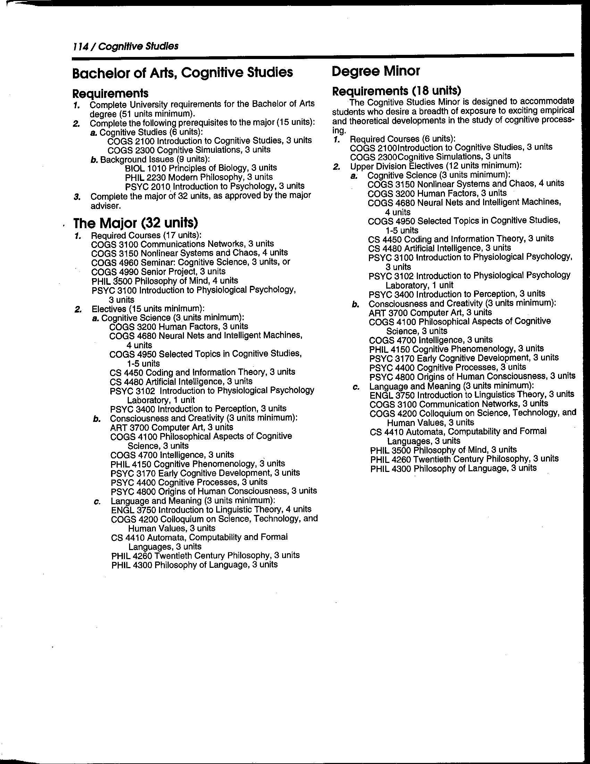

- Use a different accounting procedure.
FTES for Cogs courses are now attributed to the home department of the faculty member teaching the course.
- Increase the major’s visibility.
  - There have been mixed results in this area. When the Program underwent review for discontinuation, there were articles in the campus newspaper, but unfortunately students interpreted them as meaning that the Program had been discontinued. The vote by the Academic Senate to continue the Program was not widely recognized by students. Therefore for several years many students believed that Cognitive Studies had been discontinued, and thus didn’t consider majoring in Cogs. Other students who did understand that the Program had not been discontinued were nonetheless hesitant to major in Cogs because they were worried that there would not be campus support for the Program.
  - An important approach we took to broadening and heightening visibility was to offer more fully online classes in Cogs. Since our campus does not offer a lot of fully online classes, Cogs became a useful option for students hoping to fit additional classes into their schedules. In particular, Cogs 2100, which satisfies GE area D2b, has had robust enrollment, and has served as a valuable entry point for students to consider majoring or minoring in Cognitive Studies. Similarly, Cogs 4100, which satisfies GE area F3, has led to students minoring in Cognitive Studies.

- Achieve critical mass / Add new faculty.
As noted above, given grim economic times and budget constraints, there really has been no opportunity to build a critical mass of faculty interest in Cognitive Studies. Faculty have been discouraged from contributing time and effort to interdisciplinary programs, but rather to focus their work within their home department / program. Given these difficulties, we are recommending that the Cognitive Studies Major be suspended, while retaining the Minor, until such time as appropriate resources could be made available to give the Program a legitimate chance of being a strong success. The new discontinuation / suspension policies would be followed. Note that suspension of a program can be accomplished internally to the campus, whereas discontinuation requires Chancellor’s Office participation. If we suspend (or discontinue) the major, we will not admit new students to the program, but we will assure that all students currently in the program are able to complete their degrees.

2. Briefly describe program and field changes over the past seven years and how the curriculum was revised to address these changes.
The field of cognitive science / studies is very new and quite volatile. There does not currently exist a single well-recognized curriculum model. Programs on individual campuses reflect the particular interests and favored approaches of faculty on the campus. Our program has reflected ties with philosophy, psychology, and computer science. As noted above, we significantly revised the curriculum after the discontinuation review. Obviously, if the program is suspended, we will not need to do curriculum revision. On the other hand, if we decide to continue to offer the Major, the curriculum should be carefully reviewed with an eye toward faculty interest and availability. If we suspend the Major but keep the Minor active, the Minor should be reviewed carefully in light of the suspension, again with an eye toward faculty interest and availability. Depending on the outcome of a suspension (or discontinuation) review and decision, there may be changes in course offerings, etc., and hence more careful review of the Minor should happen along with and following that review.

B. Enrollment Trends
- Based on institutional research data, summarize program’s enrollment trends, student characteristics, retention and graduation rates, degrees conferred, and time to degree, course enrollments, and student/faculty ratio.

Nationwide there are currently about 50 universities offering degree programs in cognitive science / studies. This includes major universities such as Carnegie Mellon, Dartmouth, Indiana, MIT, and seven UC campuses. Among these, approximately one fifth offer only a minor or concentration. The only CSU campuses offering such major programs are Stanislaus and Fresno. Informally, we have heard that Fresno is considering suspending their program. These programs are all interdisciplinary in nature, and generally exist as collaborative efforts drawing faculty from multiple disciplines, not as specific departments with dedicated full faculty positions. Enrollments in Cogs classes at Stanislaus have been reasonably strong in recent years, particularly aided in recent years by fully online offerings. Here are some example data for several Cogs classes in recent years:
Cogs | S06 | W07 | S07 | F07 | W08 | S08 | F08 | W09 | S09 | W10 | S10 | F10 | S11 | F11 | S12 | F12 | S13
2100 |  |  | 22 | 23 |  | 25 | 24 |  | 34 |  | 36 | 63 |  | 35 | 35 |  | 35
2300 | 4 |  |  |  |  | 9 |  |  |  |  | 23 |  |  |  | 22
4100 | 14 |  |  |  |  | 10 |  |  |  |  | 13 |  | 34 |  |  |  | 28
4350 |  | 20 |  |  | 22 |  |  | 22 |  | 27 |  |  |  | 20 |  | 13
4960 | 3 |  |  |  |  | 9 |  |  |  |  | 12 |  |  |  | 22

As can be seen, enrollments generally have been solid in these classes, and they are paying their way in terms of FTES. Note that Cogs4350 is double listed with Hons3050 – shown here is only the Cogs enrollment.

In Spring 2013, there are 5 Cogs Majors in Cogs 4100. Majors of other students in the class include Psychology, Biology, Business and Computer Science. In Spring 2012, there were 6 Cogs Majors in Cogs 4960. Majors of other students in the class included mathematics, psychology, biology, business administration, art history, and an interdisciplinary masters student.

- Provide an evaluation of the program’s success in recruiting, retaining, and graduating students—overall and disaggregated by demographic characteristics (e.g., gender, ethnicity, and transfer/native).

As noted above, our Cognitive Studies program experienced a significant (but unintended) adverse effect from the discontinuation review process. Also, after the discontinuation review process, the Administration decided to “change leadership” for the Cognitive Studies Program. Faculty most committed to the Program, who had been teaching classes in the Program (often as voluntary overload), and mentoring and advising students were not given recognition or support for those efforts, while still being expected to contribute their efforts to the success of the Program. In practice, this did not work out very well for the Program. As of today, Dr. Carter in Computer Science is Coordinator of the Cognitive Studies program.
However, with the shift to offering various Cogs classes in a fully online format, and most particularly offering Cogs 2100 – Introduction to Cognitive Studies online, in recent years there has been an increase in student interest, and a growth both in majors and minors. The numbers of majors / minors are still too low for meaningful statistical analysis to be done, so we won’t try to do so.

Here is a brief summary of majors, minors, and graduates in recent years (2012/13 anticipated):
Cogs graduates
 | 2008/09 | 2009/10 | 2010/11 | 2011/12 | 2012/13
Major | 2 | 2 | 3 |  | 2
Minor |  | 2 | 4 | 1 | 4

As of Fall 2012, we had 13 students listing Cognitive Studies as their Major (or first Major). In addition we had a couple of students with Cognitive Studies as a second Major. We also had 8 students listing Cognitive Studies as their Minor.

C. Commitment to Student Learning
- List the learning goals for students majoring in the program. Other than grades, describe how achievement of each of these learning outcomes is evaluated and documented through both indirect and direct methods.

As a small interdisciplinary program, in practice we have worked on an individual basis with students to develop for each student a program tailored to their individual interests, goals, and academic needs. Thus, it has not been a high priority to develop global “learning goals” for all “students majoring in the program.” Through individual mentoring and advising, specific learning goals have been developed with each major and minor. The Cognitive Studies Program as listed in the catalog becomes a framework within which each student develops a program that suits them individually. This approach does require more focused attention by a faculty advisor, but provides a valuable alternative within the generic CSU model of a major or minor. We continue to believe that this semi-structured approach is rewarding for the comparatively small number of students who take advantage of it. This places Cognitive Studies somewhere in between the extremely flexible Multidisciplinary Special Major option and the wide range of traditionally structured majors. Assuming that the Major is suspended, students with a particular interest in cognitive science / studies would still be able to develop a Multidisciplinary Special Major, but would not find it as easy to discover that there are faculty on our campus in a variety of departments with these interests. This is one reason it would likely make sense to retain the Minor – to give some visibility in the catalog for the ongoing interest by various faculty in cognitive science.

C. 3. Describe changes the program faculty have made and/or plan to make as a result of surveys of current students, student exit surveys, alumni surveys, and direct methods used to evaluate student learning and program effectiveness.

See the discussion above about curriculum revision.

D. Curriculum and Instruction
- Describe the program’s effectiveness in offering the instructional program in Turlock, Stockton, and/or other off‐campus sites, and via distance education.
The coursework of the program has been offered with sufficient regularity that students have been able to complete the Major or Minor. As noted above, various classes are offered only on an alternate year basis. Also as noted above, various courses in the Program are offered in a fully online format, and this has proved to be valuable both to students and to the Program. It has increased visibility of the Program, and has resulted in students choosing Cognitive Studies for their major or minor.
- Describe issues, as appropriate related to program delivery, such as the scheduling of courses in order to meet student program needs and for program completion, and library and technological support.
The Program has been a poor stepchild. Campus support for interdisciplinary programs has been meager. Individual faculty have taught courses as voluntary overload to enable students to make appropriate progress toward their degrees. This is not a sustainable approach. In various cases, this has resulted in controversy or conflict within departments, and complaints about lack of dedication or focus by these faculty toward their “home” discipline. At this point, there are nearly no resources dedicated to the Program – to the extent that there is not even 3 wtu per year for a Program Coordinator. There are no resources available to “buy the time” of faculty across departments or colleges to offer courses to support the Program. The Program is “housed” within Computer Science, which really only means that Dr. Carter, as Chair of Computer Science, also has primary responsibility for scheduling Cogs courses, and, with the able support of Marlys Knutsen (CS Dept. Secretary), maintaining student files, handling related administrative tasks, serving as home base for Cogs Majors, etc. Dr. Carter takes primary responsibility for advising and other interactions with students.
- Describe the effectiveness of the program in improving students’ writing skills through the curriculum and/or writing proficiency courses.
Many courses taken by Cogs students have a significant writing component. Students in the Program typically take a WP course in Philosophy. There is not a specific Cogs WP course.
- Describe the effectiveness of student advising and mentoring and involvement with student majors.
As noted above, a significant portion of advising is done by Dr. Carter. Additional advising is done by Dr. Strongin and others, typically in coordination with classes the students are taking. Various faculty also help with mentoring Cogs Majors throughout their time on campus.

5. Describe the program’s role in providing service courses to other majors and the general education program.
There are several Cogs courses that satisfy General Education requirements. These include Cogs 2100 and Cogs 4100, which are both currently offered in a fully online format. As there are not a lot of online offerings (including GE), these courses provide a valuable alternative to students across the University. Dr. Carter also offers a double listed course Cogs 4350 / Honors 3050 which provides support for the Honors Program, and also satisfies a GE requirement.
If we suspend the major (as recommended), we encourages continued offering of the Minor, and with it, continued offering of these course serving the broader University community.

E. Faculty
- Describe and evaluate faculty expertise for covering the breadth of the program’s curriculum. Summarize and evaluate institutional research data regarding faculty and their deployment ‐‐ sufficiency of full and part‐time faculty, released time, and reimbursed time from grants/contracts, anticipated retirements, and other faculty issues important to the program.
There are not now, nor have their ever been, faculty with full or joint appointments in Cognitive Studies. We have depended almost entirely on the voluntary contributions of individually motivated faculty. This has primarily included faculty from Computer Science, Philosophy, and Psychology. The range of individuals involved has varied over the years, and has included Dr. Carter, Ms. Gomez, Dr. Strongin, Dr. Myers, Dr. Stanislaw, Dr. Tuedio, Dr. Wakefield and Dr. Winfree.

- Describe how faculty members are engaged and supported in scholarship, research, and/or creative activity. Describe program support for and involvement in faculty development, especially new and non‐tenured faculty.
As noted, there are no faculty officially affiliated with the Program. Dr. Carter is designated as Coordinator, but without assigned time. Thus, the Program does provide a context for various faculty efforts, but no support.

F. Implementation Plan
Preliminary Implementation Plan
As a result of the self-study, the department chair develops a preliminary implementation plan that reflects the view of the program faculty. This preliminary implementation plan is discussed with the Provost, Dean, and Vice Provost during the academic program review meeting. The implementation plan includes (but is not limited to) the following elements:
- Key recommendations of the program faculty resulting from the self‐study.
As noted above, we recommend that the Major be suspended until such time as resources and faculty time appropriate to the Program can be committed by the University. This would also be dependent on a general University commitment to the support of interdisciplinary programs in general. This might be in the form of resources along with appointment (or designation) of a Dean with responsibility for interdisciplinary and multidisciplinary programs. Current interdisciplinary/multidisciplinary offerings include the Applied Leadership BS, Environmental Sciences Concentration, Social Sciences BA, Environmental and Resource Studies Minor, Permaculture Minor, Honors Program, GE Program, and the Interdisciplinary Studies MA/MS. Conceivably, with appropriate campus support, we could explore the creation of a School of Interdisciplinary Studies, either independent from or housed within one of existing Colleges.
We recommend continuing the Minor in Cognitive Studies. Assuming the Major is suspended, we should then review the curriculum of the Minor in that new context, and formalize some commitment of resources to support the Minor, in terms of faculty, course offerings, and administrative support.

- Anticipated student profile in terms of number and type of students over the next seven years.
See above concerning suspension of the Major. Assuming we continue the Minor, we anticipate modest but ongoing growth in the Minor.

- Action steps to be taken in order to achieve each of the recommendations and student enrollments over the next seven years.
See above.
4. Types of human, fiscal, and physical resources needed to implement recommendations.
Resources will need to be allocated to allow students currently in the Major to complete their degrees. This should involve two or three courses each year for roughly the next two years.
Assuming we keep the minor, there should be 3 units of assigned time for a coordinator, and resources to offer relevant classes on an ongoing basis. As noted, Cogs courses in the Minor would often be taught fully online, and would generally be accessible to a broad range of students from various disciplines. Cogs 2100 and Cogs 4100 also satisfy GE requirements. To continue the Minor would probably require 3 or so Cogs courses (primarily sections of Cogs 2100 and Cogs 4100) to be taught each year. It would also be valuable to have 3 wtu per year for a coordinator / advocate for the Minor.

